Example of the sequence file (test.slf) for the LF-02 reader consisting in preheating and an OSL measurement, then a beta irradiation followed by two merged processes of preheating and OSL measurement. The texts written with bold letters are comments.

<?xml version="1.0" encoding="iso-8859-1"?>
<SEQ>
<Name></Name>
<STATUS>pend</STATUS> <- this is the status of the sequence
<Datecrea>2019-07-29 16:44:24.721000</Datecrea> <- sequence starting time
<Datemod>2019-07-29 16:44:24.721000</Datemod> <- sequence finishing time
Header
<Owner></Owner>
<NMuestras>1</NMuestras>
<Reader_ID>Unknown</Reader_ID>
<N2Flow>1</N2Flow>
<Doserate>0.033</Doserate>
<ExtDoserate>0</ExtDoserate>
<Protocol></Protocol>
<seq>
<Sample_ID sample="1">
<Process_order number="1"><- beginning of the description of the first process
<Status>done</Status> <- it means that the preheating is done
<Type>meas</Type>
<Process_ID id="7">
<Param>
<heating_rate>5.0</heating_rate>
<T1>220.0</T1>
<tT1>6.0</tT1>
<dT1/>
<dP1/>
</Param>
<info>
<Datatype>L0</Datatype>
<comment></comment>
</info>
<data>
<Curva1></Curva1>
<Curva2></Curva2>
<Curva3></Curva3>
<Tiempo1></Tiempo1>
<Tiempo2></Tiempo2>
</data>
</Process_ID>
</Process_order>
<Process_order number="2"><- beginning of the description of the second process
<Status>done</Status> <- this means that the OSL measurement is done
<Type>meas</Type>
<Process_ID id="3">
<Param>
<light_source>Blue</light_source>
<start_optical_power>90</start_optical_power>
<end_optical_power/>
<time>10.0</time>
<datapoints1>2</datapoints1>
<datapoints2>100</datapoints2>
<datapoints3>0</datapoints3>
<number_of_scans/>
<save_temp/>
<heating_rate>5.0</heating_rate>
<T1>125.0</T1>
<tT1>17.0</tT1>
<dT1>7.0</dT1>
<dP1/>
</Param>
<info>
<Datatype>L0</Datatype>
<comment>None</comment>
</info>
<data>
<Curva1>7;4;4562;3923;3313;2816;2320;1970;1594 ….</Curva1> <- counts
<Curva2></Curva2>
<Curva3>124.827;124.827;124.827;123.949..</Curva3><-temperature
<Tiempo1>2019-04-29T16:25:25</Tiempo1> <- time of beginning OSL
<Tiempo2>2019-04-29T16:25:35</Tiempo2> <- time of ending OSL
</data>
</Process_ID>
</Process_order>
<Process_order number="3">
<Status>done</Status>
<Type>irrad</Type>
<Process_ID id="1">
<Param>
<time>60.0</time>
<number_of_scans/>
<save_temp/>
<heating_rate>0.1</heating_rate>
<T1>0.0</T1>
<tT1>60.0</tT1>
<dT1>0.0</dT1>
<dP1/>
</Param>
<info>
<Datatype>T0</Datatype>
<comment>None</comment>
</info>
<data>
<Curva1></Curva1>
<Curva2></Curva2>
<Curva3></Curva3>
<Tiempo1>2019-04-29T16:26:50</Tiempo1><- beginning irradiation
<Tiempo2>2019-04-29T16:27:51</Tiempo2><- end irradiation
</data>
</Process_ID>
</Process_order>
<Process_order number="4"> <-here starts the description of two merged processes
<Status>pend</Status> <- it means that the merged process is pending
<Type>meas</Type>
<Process_ID id="7">
<Param>
<heating_rate>5.0</heating_rate>
<T1>220.0</T1>
<tT1>6.0</tT1>
<dT1/>
<dP1/>
</Param>
<info>
<Datatype>T0</Datatype>
<comment></comment>
</info>
<data>
<Curva1></Curva1>
<Curva2></Curva2>
<Curva3></Curva3>
<Tiempo1></Tiempo1>
<Tiempo2></Tiempo2>
</data>
</Process_ID>
<Process_ID id="3">
<Param>
<light_source>Blue</light_source>
<start_optical_power>90</start_optical_power>
<end_optical_power/>
<time>10.0</time>
<datapoints1>2</datapoints1>
<datapoints2>100</datapoints2>
<datapoints3>0</datapoints3>
<number_of_scans/>
<save_temp/>
<heating_rate>5.0</heating_rate>
<T1>125.0</T1>
<tT1>17.0</tT1>
<dT1>7.0</dT1>
<dP1/>
</Param>
<info>
<Datatype>T0</Datatype>
<comment>None</comment>
</info>
<data>
<Curva1></Curva1>
<Curva2></Curva2>
<Curva3></Curva3>
<Tiempo1></Tiempo1>
<Tiempo2></Tiempo2>
</data>
</Process_ID>
</Process_order>
</Sample_ID>
</seq>
</SEQ> <- end of the sequence file

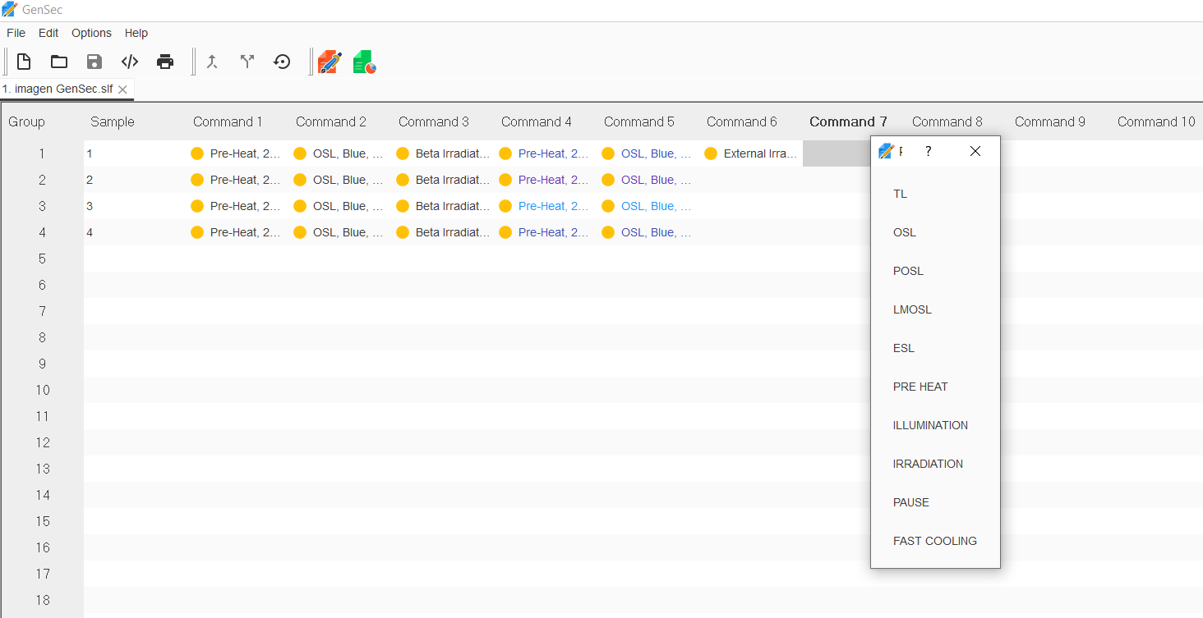
View of the GenSec software for generating the sequence files for LF02 reader.
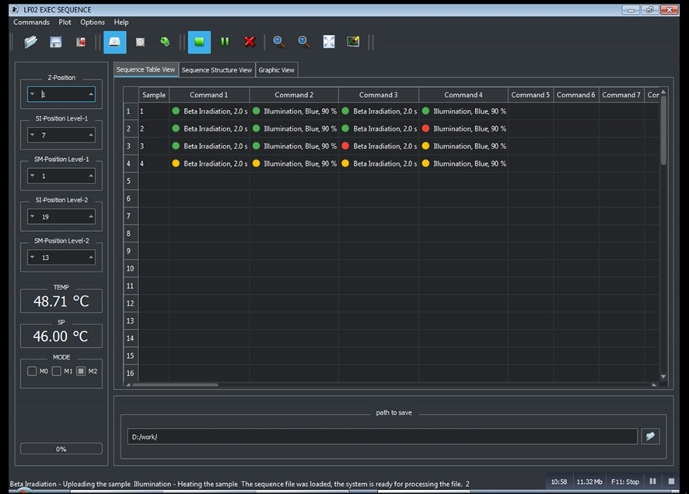
View of the GenExe software controlling the execution of sequences in LF02 reader. Yellow filled circles represent pending processes, red circles are process in execution and green circles are the processes already finished.

